# BASIC LINUX COMMANDS

1. mkdir : Create a new directory with given name.
2. ls : Lists the content of dictionary and directories.

With “mdkir” we created a directory and with “ls” we checked if our directory is created as we can see BASIC-LINUX directory is listed by “ls” command and all the other that were giver in blue are directories that were already present.

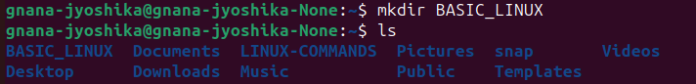

1. cd : Change of directory.





1. touch : Create empty file.

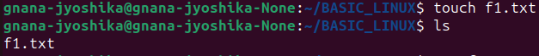

1. cat>filename : It can create and write into a new file.

Use “ctrl+d” to save in the file.



1. Cat : Display content of the file.



1. cat file1 file2>file3 : This can merge 2 files and copy the content into another file.

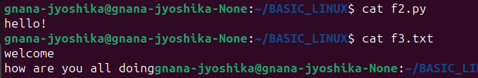





1. ls*.txt : it will list all the files in the given extension.

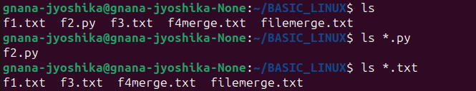

1. Pwd : Displays the current working directory.



1. cp file : Copy the file or a directory to another.
2. mv : Moves a file to another directory.
3. vi file : It is a text editor to write programs of texts.
4. head : Display top or first 10 lines of the file.

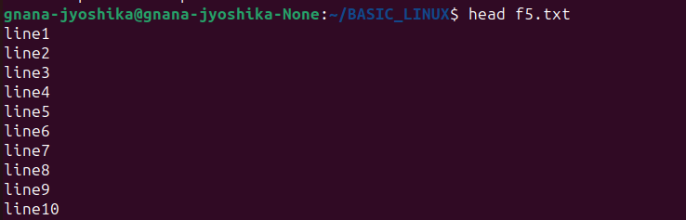

1. trail file : Displays last 10 lines of the file.

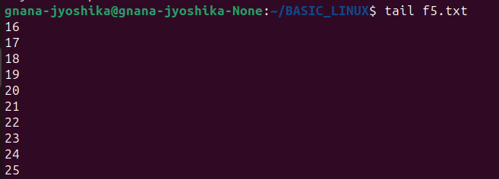

1. More : displaying the content one after the other using enter or space bar once the content is beyond the screen size.



1. tac file : tac is reverse of cat its displays data in file in the reverse order.

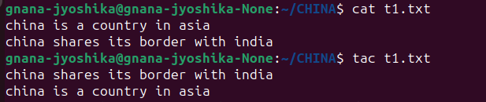

1. id : Display id of user or group.

As shown here it will gives user id, group id and other things.



1. clear : Content on the screen will be removed



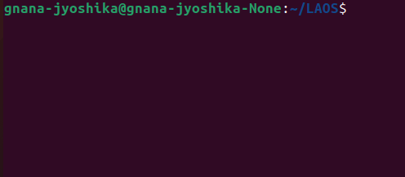

1. greap : Filter to search the given pattern in the file content



1. diff : It compares the content of two different files and displays the difference between them.

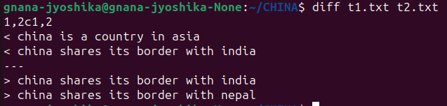

1. ping : y Checks the connectivity status of the server.

You can use “ctrl+z” to stop that process.

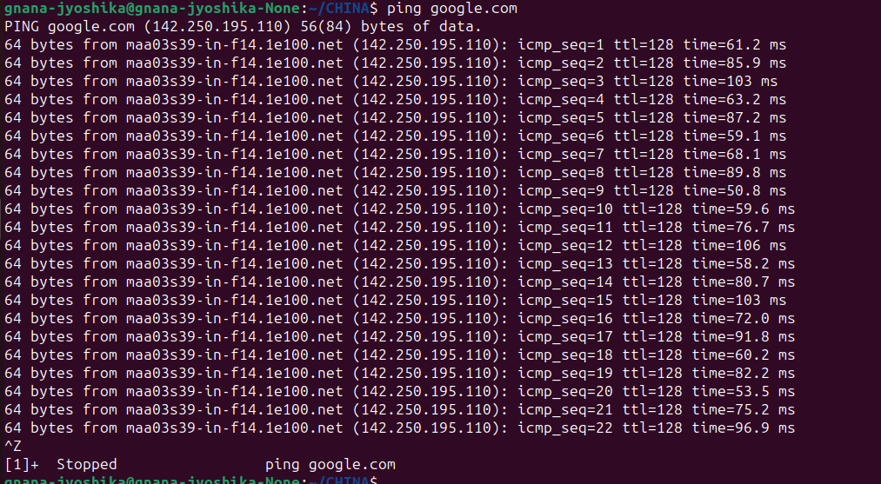

1. history : It reviews all the commands you have entered so far.

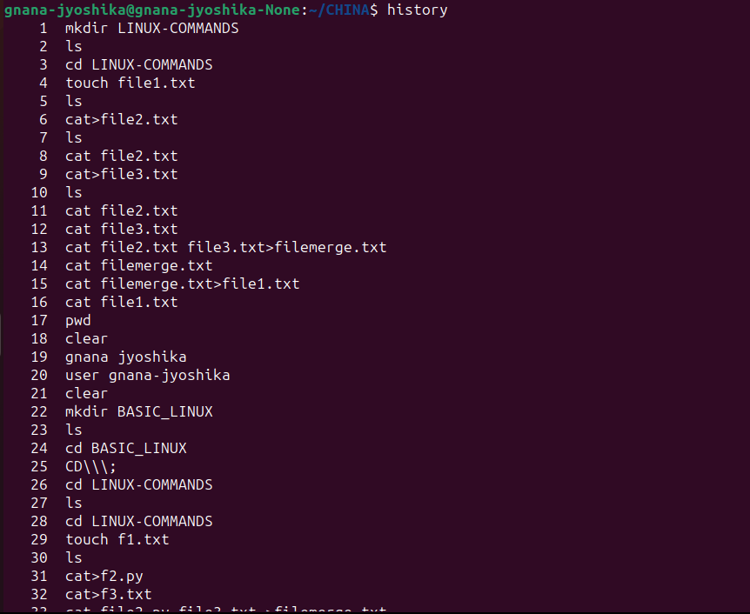

1. display host name : It displays the host name.
2. hostname-I : Displays the host ip address. As shown in the program below host name and there ip address can be displayed.

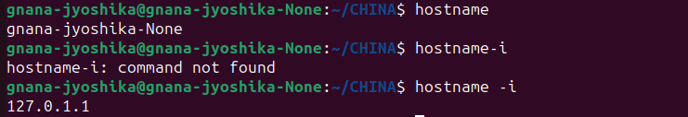

1. chmod : Change the user or group permission to access the files.

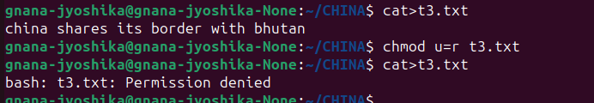

1. nl : It displays the file content with serial numbers.



1. wc : It displays the number of lines, words and characters avliable in the given file.



1. uniq : Removes the duplicates of the file content which only are in continuous lines.

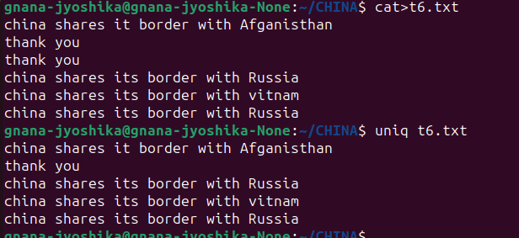

1. rmdir : removes the specific directory only if its empty.

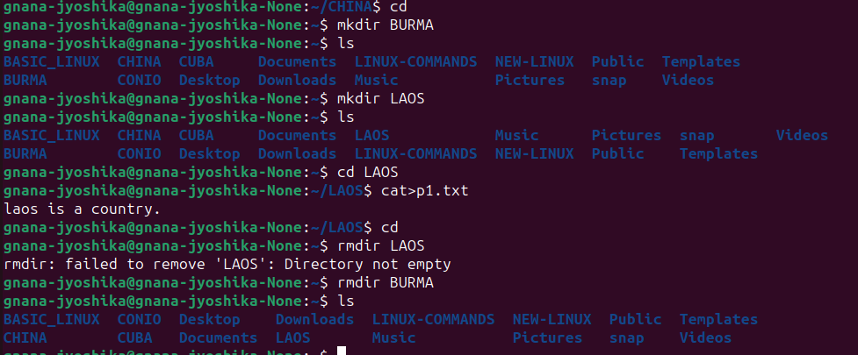

1. rm : Removes the specific file in the directory.

